Python
Introduction
High level programming language developed by GUIDO VAN ROSSUM in 1991.
Known for its:
- Readability
- Wide and strong library support
- Easier to understand
- Used in data science, automation, AI, web development and more
- Object oriented
- Dynamic typing

Libraries:
- Numpy: numerical computing, arrays, matrices, mathematical operations
- Pandas: data manipulation, cleaning, analysis, dataframes
- Polars: alt to pandas, used for fast dataframe/data processing alternatives to pandas
- Scipy: scientific computing, optimization, statistics, linear algebra
- Matplotlib: basic data visualization and plotting
- Beautfiful soup: web scraping and HTML parsing
- Pydantic: data validation and structured data models
- Tensorflow: deep learning & neural networks
- Opencv: computer vision

Frameworks:
- Django: full stack web development
- Flask: lightweight web backend
- Fastapi: high performance API development

Difference between library and framework
- Library: collection of pre written helper functions, you call it when u need it
- Framework: comprehensive skeletal structure or blueprint, provides the overall foundation for building an application, calls your code and enforces a way of doing things

Why python?
- Works on different platforms (windows, mac, linux, raspberry pi, etc)
- Simpler syntax
- Quick prototyping – runs on an interpreter system, code can be executed as soon as its written

IDEs – pycharm, vs code, pydev, jupyter ntbk, spyder, google colab, cursor, thonny, python idle, sublime text, mu

Relies on whitespaces for indentation, other languages use curly braces.

Comments
- Explains code
- Makes code more readable
- Use to prevent execution when testing code
- Created using: “#”
- Python ignores everything written after “#” atleast in the same line
- Multiline comments use: [“””] or [‘’’]

Unpacking - python allows to extract values from list/tuple into variables
List: []
Tuple: ()
Set: {}

Variables
- Anything that can change, vary, and is not fixed/constant.
- In cs, it’s a storage location in memory that holds a value which your program can change later.
- Python has no commands for declaring it
- Can get the data type of a variable with the type() function
- Strings can be declared using single/double quotes

Rules for Variable names:
- Must start with letter or underscore(_)
- Cannot start with number
- Can only contain alphanumeric characters
- Case sensitive
- Cannot be any of the keywords

Multi words variable names:
- Camel case: myVariableName
- Pascal case: MyVariableName
- Snake case: my_variable_name

Statements
- A program is a list of “instructions” to be “executed” by a computer
- These programming instructions are called statements
- Statement ends when line ends
- In python, semicolon(;) is not needed for that, unlikle some other languages
- Executed in the order they are written
- Syntactically legal(but unnecessary at most places), python treats it as a statement separator
- Writing 2 statements in a row w/o a separator will give an error

“print()” – used to display text or output values
Quotes – text to be written inside quotes, can use single (‘) or double(“) quotes both

By default, print() ends with a new line.
If want to print multiple words on same line use: “,end =‘ ’” inside print()

Global variables: created outside a function, can be used/accessed by anyone both inside and outside the function.

Local variables: created inside a function, can be ONLY used/accessed inside that function.

Keywords: total 39 (35 normal keywords + 4 soft keywords)

Global keyword: To set a local variable as global, use “global” keyword. We use it when we need to modify the value of a global variable inside a function.
! HOWEVER !, using the GLOBAL keyword will change the value for the entire program

Data Types
Core data types -> 4
Total data types -> 14

Numeric : int, float, complex
Sequence: str, list, tuple, range
Mapping: dict
Set type: set, frozenset
Boolean: bool
None type: nonetype
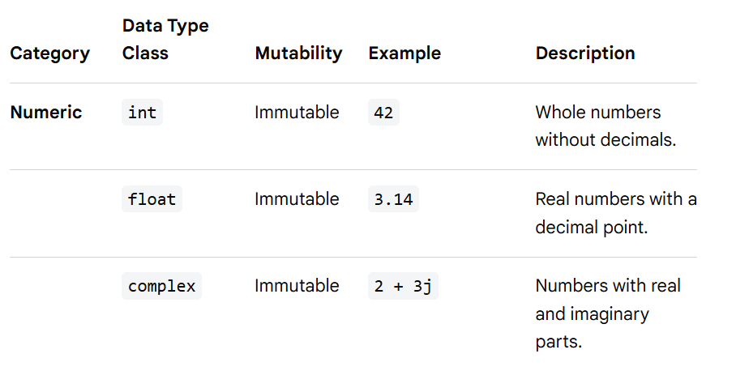
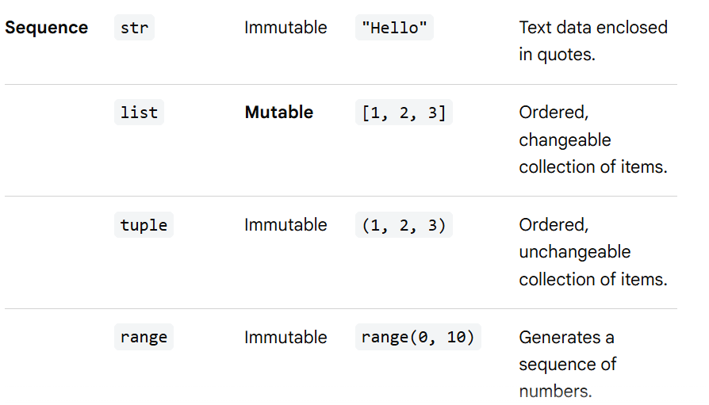
Unordered in older versions
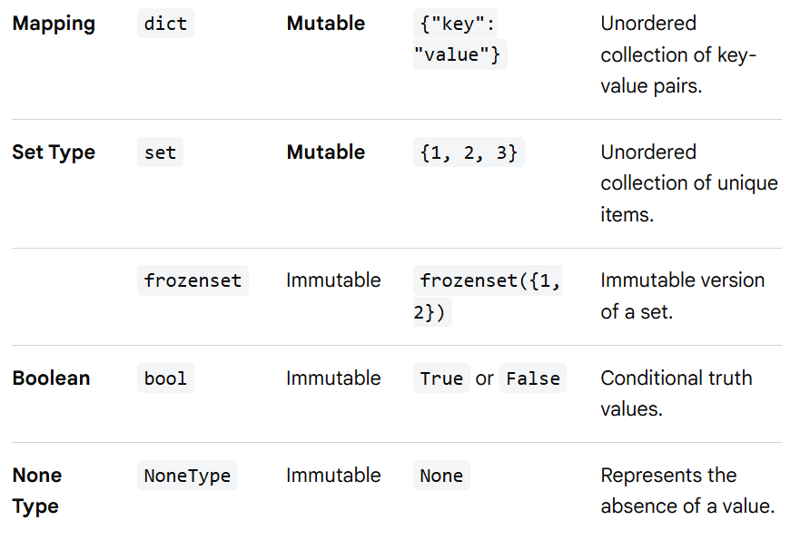
Type conversion
Can convert one type to another with int(), float(), complex() methods

Python has a built in module called random that can be used to make random numbers.

Object oriented language hence uses classes to define data types including its primitive datatypes.
Primitive : int, float, complex, bool, str, NoneType
Derived: list, tuple, set, frozenset, dict

Strings
- Surrounded by single/double quotation marks
- Arrays of unicode characters
- Square brackets are used to access elements(characters not words) of the string
- Length of string – len()
- “in” keyword to check if character/word present in a string
- “not in” keyword for the opposite purpose
- Slicing can be done as: var[start:stop:step]
- Some methods to modify strings: upper(), lower(), strip() -> removes white space,replace(), split()
- Concatenate: use “+”
- Can combine str and int using format() method
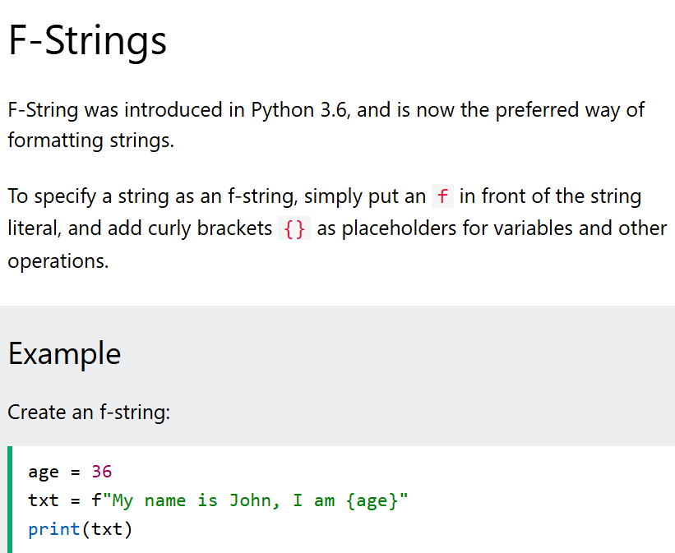
- Escape characters are used to insert the characters that are otherwise illegal, reserved, or difficult to type directly into a string literal
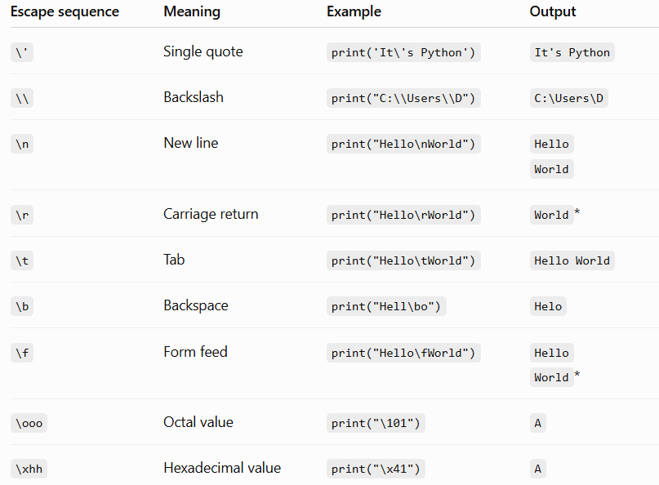
- String methods
Method | Description
capitalize() | Converts the first character to upper case
casefold() | Converts string into lower case
center() | Returns a centered string
count() | Returns the number of times a specified value occurs in a string
encode() | Returns an encoded version of the string
endswith() | Returns true if the string ends with the specified value
expandtabs() | Sets the tab size of the string
find() | Searches the string for a specified value and returns the position of where it was found
format() | Formats specified values in a string
format_map() | Formats specified values in a string
index() | Searches the string for a specified value and returns the position of where it was found
isalnum() | Returns True if all characters in the string are alphanumeric
isalpha() | Returns True if all characters in the string are in the alphabet
isascii() | Returns True if all characters in the string are ascii characters
isdecimal() | Returns True if all characters in the string are decimals
isdigit() | Returns True if all characters in the string are digits
isidentifier() | Returns True if the string is an identifier
islower() | Returns True if all characters in the string are lower case
isnumeric() | Returns True if all characters in the string are numeric
isprintable() | Returns True if all characters in the string are printable
isspace() | Returns True if all characters in the string are whitespaces
istitle() | Returns True if the string follows the rules of a title
isupper() | Returns True if all characters in the string are upper case
join() | Joins the elements of an iterable to the end of the string
ljust() | Returns a left justified version of the string
lower() | Converts a string into lower case
lstrip() | Returns a left trim version of the string
maketrans() | Returns a translation table to be used in translations
partition() | Returns a tuple where the string is parted into three parts
replace() | Returns a string where a specified value is replaced with a specified value
rfind() | Searches the string for a specified value and returns the last position of where it was found
rindex() | Searches the string for a specified value and returns the last position of where it was found
rjust() | Returns a right justified version of the string
rpartition() | Returns a tuple where the string is parted into three parts
rsplit() | Splits the string at the specified separator, and returns a list
rstrip() | Returns a right trim version of the string
split() | Splits the string at the specified separator, and returns a list
splitlines() | Splits the string at line breaks and returns a list
startswith() | Returns true if the string starts with the specified value
strip() | Returns a trimmed version of the string
swapcase() | Swaps cases, lower case becomes upper case and vice versa
title() | Converts the first character of each word to upper case
translate() | Returns a translated string
upper() | Converts a string into upper case
zfill() | Fills the string with a specified number of 0 values at the beginning

Boolean : True or False. Bool() function allows us to evaluate any value and give True/False in return

Operators: 9 types in python
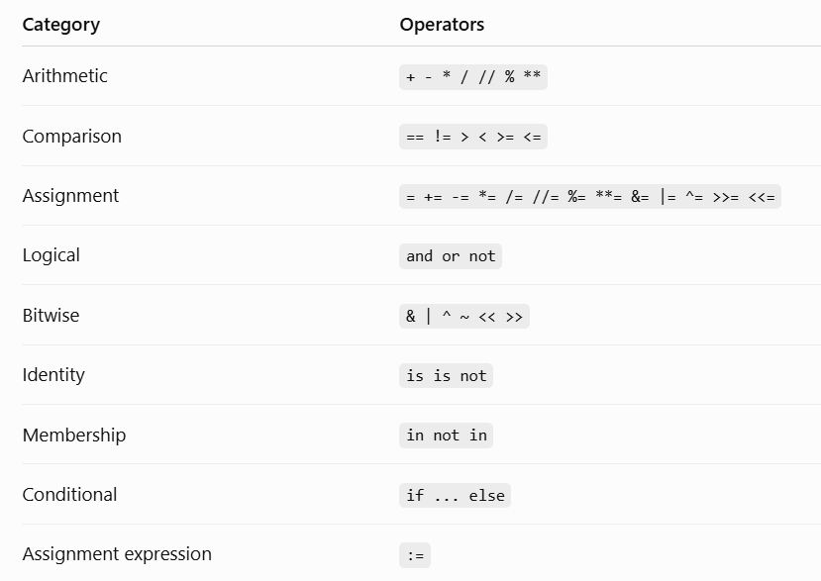
Walrus operator (:=) lets us assign a value to a variable and use the value immediately in the same expression.
Ternary operator ( conditional expression) is a 1 line alternative to traditional if-else statement
Value_if_true if condition else value_if_false

Difference between is and ==
Is – checks if both point to the same object in memory
== - checks if the values of both variables are equal

Bitwise operators used to compare binary numbers

Precedence order
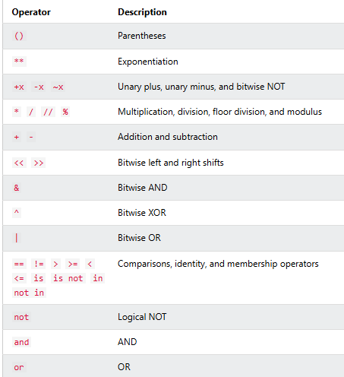

List
- Multiple items in single variable
- Ordered
- Mutable
- Allows duplicates
- [] brackets
- Accessed through index values
- List functions
- Len() – length of list
- Index() – returns index of the 1st occurrence of a specified value
- Insert() – inserts item at specified index # eg. x.insert(2,”apple”)
- Append() – adds item at the end of the list
- Extend() – appending elements from other list to current , can also be done using ‘+’ operator
- Removes() – removes specified item
- Pop() – removes item from specified index, if index not specified removes the last item by default
- Del() – removes the item at specified index
- Clear() – empties the list, but the list remains
- Sort() – sorts the list alphanumerically in ascending order by default, for descending, use “reverse = True”. Uppercase before lowecase. If need case insensitive sorting use key=str.lower
- Reverse() – order reversed irrespective of alphabetic sequence
- Copy() – copies 1 list into another, another way is list(), can also use x[:] (the slicing operator
- List comprehension : shortest way to loop through lists

Tuples
- indexed
- Ordered
- Immutable/unchangeable
- Allows duplicates
- Uses () brackets
- Cannot remove items from a tuple, still if needed:
- Tuple->list(remove item)->tuple
- Tuples can be deleted entirely
- Can also be created without parantheses
- Rest functions are same as that of list
- How to change tuple values?
- Tuple->list(update/change/add value)->tuple
- Can add 2 tuples together, and even multiply them (repetition)
- Packing: putting multiple values in a tuple
- Unpacking: taking out values from the tuple and assigning them to separate variables. “*” can be used when count(var)<count(elements(tuple)), it will print them all as a list

Sets
- Unindexed
- Unordered
- Unchangeable/immutable
- Duplicates not allowed
- Can remove/add items
- Uses {} brackets
- True is same as 1, False is same as 0 in sets hence only 1 of each pair gets printed(duplicate eliminated)
- Cannot access the values using index, as unordered(either use loop or use in/not in operator with the specific value)
- Add() – can add items to the set (gets added to the last)
- Update() – adds 1 set to another, can also add any iterable object to the set
- Remove() and discard() – both are used to remove elements from the set. Remove() raises error if that element doesn’t exist, discard() doesn’t.
- Pop() is used to remove item too, but we’re not sure what item will be removed – as sets are unordered
- Clear() – used to remove the values, set remains even if empty
- Del() – set is completely deleted
- Joining sets:
- Union() – combines both sets and returns new set ( original sets remain unchanged)
- Update() – adds elements from 1 set to another and returns the modified set (only the set to which other elements from different set are added, is modified)
- Intersection() – will only return the duplicate value/s, can also use (&) operator
- Intersection_update() – will return the duplicates but in the original(modified) set
- Difference() _ will return a new set that will have only unique elements from the 1st set which are not present in the other set, can also use the “-“ operator
- Difference_update() – will return the unique values in 1st set(which arent present in other) but in the original(modified) set
- Symmetric_difference() – will return a new set which has unique elements of both sets, can also use “^”
- Symmetric_difference_update() - will return an original set(modified) which has unique elements of both sets

Frozenset
- Immutable version of sets
- Unordered
- Unindexed
- Unchangeable
- Cannot even add/remove values from a frozenset
- Can create a copy of frozenset

Dictionary
- Ordered (Python 3.6 and earlier versions were unordered)
- Mutable
- Duplicates not allowed (unique keys, values can be duplicate)
- Stores data in key:value pairs
- Can access the items of a dictionary by referring to its key name as: dict1[“name”]. can also use get() method. Difference wil be that: get() method wont throw an error if a key doesn’t exist, whereas the regular method does
- Keys() – will return a list of all keys in a dictionary
- Values() – will return list of all values in a dictionary
- Items() – will return list of all items in a dictionary
- Update() – will update dictionary with the already existing key/s, or add a new key:value pair
- Pop() – removes the item with specified key name
- Popitem() – removes last inserted item
- Del() – removes specified item from dictionary

Difference between pop() and del()
Pop() removes a specified key and returns its value
Del() simply removes the key, without returning anything

- Clear() – empties the dictionary, but doesn’t delete it

